

MANAV RACHNA
INTERNATIONAL SCHOOL
NOIDA

COMPUTER SCIENCE PROJECT
VMC Electronics
(An e-commerce website)

Student Names: Dev Babbar & Abhay Mehta
Grade: XI-Einstein
Roll No: 4 & 1
Session: 2018-2019

Certificate

This is to certify that Dev Babbar and Abhay Mehta studying in grade XI have successfully completed the computer science project for the year 2018-2019.

Ms. Sakshi Gandotra Ms. Nindiya Saket
Faculty Principal

Acknowledgement

We would like to express our special thanks of gratitude to our teacher
Ms. Sakshi Gandotra as well as
our principal Ms. Nindiya Saket who
gave us the golden opportunity to do
this wonderful project on trying
to develop a website
like Apple.

Index

Serial No. | Topic | Page No.
1. | Certificate | 2
2. | Acknowledgement | 3
3. | Introduction | 5
4. | System Requirements | 6
5. | Salient Features | 7
6. | Code | 8
7. | Output | 20
8. | Scope of Improvement | 25
9. | Bibliography | 26

Introduction

Our Computer science teacher made the pairs and gave us topic to start working on. Our topic was e-commerce. We researched about some existing e-commerce websites with not a huge variety of categories because it wouldn’t be possible to add so many. We concluded that Apple.com would be a good website because of small number of products they have.

We started working on the product together, we usually talked over discord and whatsapp. We faced problems in the login and signup part and total price part. Website looked great, our final code had 542 lines which is also an achievement taking in account, we started working on the code late.

System Requirements

Main Processor: Intel Atom® processor / Intel® Core™ i3 processor or later

Hard Disk: 2-3 GB

RAM: 2 GB

Operating System: Windows 7 or later / Linux / macOS

Language: Python

Salient Features

Our e-commerce website has features like:
- Login/Signup
- Booking multiple products like mobile phones, tablets, laptops, Watches, TVs, Headphones/earphones etc.
- Website shows variety of products to choose from and specification which match with existing products.
- Cart
- Choosing mode of payment and collecting an address.

Code
import time

# Start Program

users={'AMAR': 'nath', 'ABHAY': 'mehta','DEV':'babbar'}
status=""
loginSuccess=0
global cartTotal
Cart=[]
Rate=[]

def headerBanner():
print("\n"*5)
print("\nWelcome to VMC Electronics")
print("==========================\n")

def ShoppingCart():
headerBanner()
print("What would you like to buy today?")
print("[1] Mobile")
print("[2] Tablets")
print("[3] Laptop")
print("[4] Watch")
print("[5] TV")
print("[6] Earphones/Headphones")
print("\n")
print("[7] Check-Out")
print("\n")
print("[8] Rate Us/ Complain")
print("[0] Quit ")
mainCategory=input("\nChoose your option? ")
if mainCategory=="1":
mobileShop()
elif mainCategory=="2":
tabletShop()
elif mainCategory=="3":
laptopShop()
elif mainCategory=="4":
watchShop()
elif mainCategory=="5":
tvShop()
elif mainCategory=="6":
headphoneShop()
elif mainCategory=="7":
CheckOutCart()
elif mainCategory=="8":
headerBanner()
Rating=input("Enter your review or complain here: ")
print("Thanks for your feedback/ review.")
print("We will get in touch with you with the resolution/ update.\n")
input("Press any key to continue...")
elif mainCategory=="0":
exit()

def DisplayMenu():
ShoppingCart()

def loginShop():
headerBanner()
status=input("[L]ogin/ [S]ign-up/ [Q]uit? ").upper()
if status=="L":
OldUser()
elif status=="S":
NewUser()
elif status=="Q":
exit()
else:
loginShop()

def NewUser():
headerBanner()
print("Sign-Up (New User)")
print("==================\n")
createLogin=input("New User name:").upper()
if createLogin in users:
print("\nUser Name already exists!\nChoose another...")
input("Press any key to continue...")
loginSuccess=1
loginShop()
else:
createPassword=input("Password: ")
users[createLogin]=createPassword
print("\nUser Created...\n")
input("Press any key to continue...")
loginSuccess=0

def OldUser():
headerBanner()
print("Login (Existing User)")
print("=====================\n")
login=input("User Name: ").upper()
password=input("Password: ")
if(login in users and users[login]==password):
print("\nLogin successful!\n")
input("Press any key to continue...")
loginSuccess=0
else:
print("User doesn't exist or wrong password!\n");
input("Press any key to continue...")
loginSuccess=1
loginShop()

def mobileShop():
global cartTotal
headerBanner()
print("Mobile Shop")
print("===========\n")
AddToCart="0";
print("[1] FPhone 8 | $799")
print("[2] FPhone 10 | $999")
print("[3] FPhone 10X | $1099")
print("[4] FPhone 10 Max | $1199")
print("\n")
print("[7] Check-Out")
print("\n")
print("[9] Prvious Menu")
print("[0] Quit")
shopOption=input("Choose your option? ")
if shopOption=="1":
print("OS : iOS 10")
print("Display : 4.7\" Retina")
print("Weight : 148gm")
print("Dimension : 1334 x 750")
print("RAM : 2GB")
print("Camera : 12MP")
print("Resolution: 2160p")
print("Battery : 1821mAh")
print("Memory : 64GB")
print("[1] Add to cart, [2] Go Back")
AddToCart=input("Choose your option? ")
if AddToCart=="1":
Cart.append("Fphone 8 : $799")
cartTotal=cartTotal+799
mobileShop()
elif AddToCart=="2":
mobileShop()
else:
print("We didn't get any valid response, returning to main menu...")
mobileShop()
elif shopOption=="2":
print("OS : iOS 11.1.1")
print("Display : 5.8\" Retina")
print("Weight : 174gm")
print("Dimension : 1125 x 2436")
print("RAM : 3GB")
print("Camera : 12MP")
print("Resolution: 2160p")
print("Battery : 2716mAh")
print("Memory : 256GB")
print("[1] Add to cart, [2] Go Back")
AddToCart=input("Choose your option? ")
if AddToCart=="1":
Cart.append("Fphone 10 : $999")
cartTotal=cartTotal+999
mobileShop()
elif AddToCart=="2":
mobileShop()
else:
print("We didn't get any valid response, returning to main menu...")
mobileShop()
elif shopOption=="3":
print("OS : iOS 12")
print("Display : 5.8\" Retina")
print("Weight : 177gm")
print("Dimension : 1125 x 2436")
print("RAM : 4GB")
print("Camera : 12MP")
print("Resolution: 2160p")
print("Battery : 2658mAh")
print("Memory : 256GB")
print("[1] Add to cart, [2] Go Back")
AddToCart=input("Choose your option? ")
if AddToCart=="1":
Cart.append("Fphone 10X : $1099")
cartTotal=cartTotal+1099
mobileShop()
elif AddToCart=="2":
mobileShop()
else:
print("We didn't get any valid response, returning to main menu...")
mobileShop()
elif shopOption=="4":
print("OS : iOS 12")
print("Display : 6.5\" Retina")
print("Weight : 208gm")
print("Dimension : 1242 x 2688")
print("RAM : 4GB")
print("Camera : 12MP")
print("Resolution: 2160p")
print("Battery : 3174mAh")
print("Memory : 512GB")
print("[1] Add to cart, [2] Go Back")
AddToCart=input("Choose your option? ")
if AddToCart=="1":
Cart.append("Fphone 10X Max : $1199")
cartTotal=cartTotal+1199
mobileShop()
elif AddToCart=="2":
mobileShop()
else:
print("We didn't get any valid response, returning to main menu...")
mobileShop()
elif shopOption=="7":
CheckOutCart()
elif shopOption=="9":
ShoppingCart()
elif shopOption=="0":
exit()

def tabletShop():
global cartTotal
headerBanner()
print("TabletnShop")
print("===========\n")
AddToCart="0";
print("[1] Fpad 6 | $499")
print("[2] Fpad 7 | $799")
print("[3] Fpad 8 | $999")
print("[4] Fpad 8 Pro | $1099")
print("\n")
print("[7] Check-Out")
print("\n")
print("[9] Prvious Menu")
print("[0] Quit")
shopOption=input("Choose your option? ")
if shopOption=="1":
print("OS : iOS 8.1(Base)")
print("Display : 9.7\" Retina")
print("Weight : 437gm")
print("Dimension : 1536 x 2048")
print("RAM : 2GB")
print("Camera : 8MP")
print("Resolution: 1080p")
print("Battery : 7340mAh")
print("Memory : 64GB")
print("[1] Add to cart, [2] Go Back")
AddToCart=input("Choose your option? ")
if AddToCart=="1":
Cart.append("Fpad 6 : $499")
cartTotal=cartTotal+499
tabletShop()
elif AddToCart=="2":
tabletShop()
else:
print("We didn't get any valid response, returning to main menu...")
tabletShop()
elif shopOption=="2":
print("OS : iOS 11.3")
print("Display : 9.7\" Retina")
print("Weight : 469gm")
print("Dimension : 1536 x 2048")
print("RAM : 2GB")
print("Camera : 8MP")
print("Resolution: 2160p")
print("Battery : 8827mAh")
print("Memory : 128GB")
print("[1] Add to cart, [2] Go Back")
AddToCart=input("Choose your option? ")
if AddToCart=="1":
Cart.append("Fpad 7 : $799")
cartTotal=cartTotal+799
tabletShop()
elif AddToCart=="2":
tabletShop()
else:
print("We didn't get any valid response, returning to main menu...")
tabletShop()
elif shopOption=="3":
print("OS : iOS 12")
print("Display : 11.9\" Retina")
print("Weight : 468gm")
print("Dimension : 1668 x 2388")
print("RAM : 4GB")
print("Camera : 12MP")
print("Resolution: 2160p")
print("Battery : 8812mAh")
print("Memory : 1TB")
print("[1] Add to cart, [2] Go Back")
AddToCart=input("Choose your option? ")
if AddToCart=="1":
Cart.append("Fpad 8 : $999")
cartTotal=cartTotal+999
tabletShop()
elif AddToCart=="2":
tabletShop()
else:
print("We didn't get any valid response, returning to main menu...")
tabletShop()
elif shopOption=="4":
print("OS : iOS 12")
print("Display : 12.5\" Retina")
print("Weight : 550gm")
print("Dimension : 1788 x 2688")
print("RAM : 4GB")
print("Camera : 12MP")
print("Resolution: 2500p")
print("Battery : 9000mAh")
print("Memory : 1TB")
print("[1] Add to cart, [2] Go Back")
AddToCart=input("Choose your option? ")
if AddToCart=="1":
Cart.append("Fpad 8 Pro : $1099")
cartTotal=cartTotal+1099
tabletShop()
elif AddToCart=="2":
tabletShop()
else:
print("We didn't get any valid response, returning to main menu...")
tabletShop()
elif shopOption=="7":
CheckOutCart()
elif shopOption=="9":
ShoppingCart()
elif shopOption=="0":
exit()

def laptopShop():
global cartTotal
headerBanner()
print("Laptop Shop")
print("===========\n")
AddToCart="0";
print("[1] Macbook2 | $1499")
print("[2] Macbook3 | $1999")
print("\n")
print("[7] Check-Out")
print("\n")
print("[9] Prvious Menu")
print("[0] Quit")
shopOption=input("Choose your option? ")
if shopOption=="1":
print("CPU : 2.3GHz Quad Core")
print("Processor : Intel Core i5-based")
print("Monitor : 13\"")
print("RAM : 8GB")
print("HDD/ SSD : 512GB SSD")
print("[1] Add to cart, [2] Go Back")
AddToCart=input("Choose your option? ")
if AddToCart=="1":
Cart.append("Macbook2 : $1499")
cartTotal=cartTotal+1499
laptopShop()
elif AddToCart=="2":
laptopShop()
else:
print("We didn't get any valid response, returning to main menu...")
laptopShop()
elif shopOption=="2":
print("CPU : 2.6GHz quad-core")
print("Processor : Intel Core i7-based")
print("Monitor : 15\"")
print("RAM : 8GB")
print("HDD/ SSD : 1TB SSD")
print("[1] Add to cart, [2] Go Back")
AddToCart=input("Choose your option? ")
if AddToCart=="1":
Cart.append("Macbook3 : $1999")
cartTotal=cartTotal+1999
laptopShop()
elif AddToCart=="2":
laptopShop()
else:
print("We didn't get any valid response, returning to main menu...")
laptopShop()
elif shopOption=="7":
CheckOutCart()
elif shopOption=="9":
ShoppingCart()
elif shopOption=="0":
exit()

def watchShop():
global cartTotal
headerBanner()
print("Watch Shop")
print("==========\n")
AddToCart="0";
print("[1] Max Watch | $799")
print("[2] Max Watch Pro | $999")
print("\n")
print("[7] Check-Out")
print("\n")
print("[9] Prvious Menu")
print("[0] Quit")
shopOption=input("Choose your option? ")
if shopOption=="1":
print("Dimensions : 41.5 x 35.4 x 11.4 mm (1.67 x 1.43 x 0.45 Inch)")
print("Weight : 52.4gm (1.83 oz)")
print("Body : Build Stainless Steel/Ceramic back")
print("Waterproof : 50m")
print("SIM : No")
print("[1] Add to cart, [2] Go Back")
AddToCart=input("Choose your option? ")
if AddToCart=="1":
Cart.append("Max Watch : $799")
cartTotal=cartTotal+799
watchShop()
elif AddToCart=="2":
watchShop()
else:
print("We didn't get any valid response, returning to main menu...")
watchShop()
elif shopOption=="2":
print("Dimensions : 43.5 x 37.4 x 11.4 mm (1.67 x 1.43 x 0.45 Inch)")
print("Weight : 52.4gm (1.83 oz)")
print("Body : Build Stainless Steel/Ceramic back")
print("Waterproof : 50m")
print("SIM : -")
print("[1] Add to cart, [2] Go Back")
AddToCart=input("Choose your option? ")
if AddToCart=="1":
Cart.append("Max Watch Pro : $999")
cartTotal=cartTotal+999
watchShop()
elif AddToCart=="2":
watchShop()
else:
print("We didn't get any valid response, returning to main menu...")
watchShop()
elif shopOption=="7":
CheckOutCart()
elif shopOption=="9":
ShoppingCart()
elif shopOption=="0":
exit()

def tvShop():
global cartTotal
headerBanner()
print("TV Shop")
print("=======\n")
AddToCart="0";
print("[1] Max TV | $1599")
print("\n")
print("[7] Check-Out")
print("\n")
print("[9] Prvious Menu")
print("[0] Quit")
shopOption=input("Choose your option? ")
if shopOption=="1":
print("Model : 65 Q9F")
print("Description : 4K Smart QLED TV, , , ")
print(" : Q Colour")
print(" : Q Contrast")
print(" : Q HDR Elite (HDR 10+)")
print("[1] Add to cart, [2] Go Back")
AddToCart=input("Choose your option? ")
if AddToCart=="1":
Cart.append("Max TV : $1599")
cartTotal=cartTotal+1599
tvShop()
elif AddToCart=="2":
tvShop()
else:
print("We didn't get any valid response, returning to main menu...")
tvShop()
elif shopOption=="7":
CheckOutCart()
elif shopOption=="9":
ShoppingCart()
elif shopOption=="0":
exit()

def headphoneShop():
global cartTotal
headerBanner()
print("Headphone Shop")
print("==============\n")
AddToCart="0";
print("[1] Wireless God | $100")
print("[2] Gaming God | $300")
print("\n")
print("[7] Check-Out")
print("\n")
print("[9] Prvious Menu")
print("[0] Quit")
shopOption=input("Choose your option? ")
if shopOption=="1":
print("Description/ Features : JBL Signature Sound")
print(" : Up to 16-hour battery life")
print(" : Two-hour recharge time")
print(" : Comfort-fit fabric headband")
print(" : One-button universal remote with microphone")
print("[1] Add to cart, [2] Go Back")
AddToCart=input("Choose your option? ")
if AddToCart=="1":
Cart.append("Wireless God : $100")
cartTotal=cartTotal+100
headphoneShop()
elif AddToCart=="2":
headphoneShop()
else:
print("We didn't get any valid response, returning to main menu...")
headphoneShop()
elif shopOption=="2":
print("Description/ Features : Latency-free wireless performance audio on PC and works with PS4")
print(" : Wireless 7.1 virtual surround sound for pinpoint precision")
print(" : 7 days of wireless gaming on a single charge")
print(" : Retractable digital mic for uncompromised vocal clarity")
print(" : 1 Year Warranty")
print("[1] Add to cart, [2] Go Back")
AddToCart=input("Choose your option? ")
if AddToCart=="1":
Cart.append("Gaming God : $300")
cartTotal=cartTotal+300
headphoneShop()
elif AddToCart=="2":
headphoneShop()
else:
print("We didn't get any valid response, returning to main menu...")
headphoneShop()
elif shopOption=="7":
CheckOutCart()
elif shopOption=="9":
ShoppingCart()
elif shopOption=="0":
exit()

def CheckOutCart():
headerBanner()
print("Check-Out Cart")
print("==============\n")
for item in Cart:
print(item)
print(" =======")
print(" $", cartTotal)
Modeofpay=input("Press 1 to pay with Cash, Press 2 to pay with Credit card/Debit Card:")
Address=input("Enter your delivery address:")
if Modeofpay=="1":
print("Your product will be delivered to",Address,"by next 5 days. Keep your $",cartTotal,"ready")
elif Modeofpay=="2":
print("We have recieved your payment of $",cartTotal," Your product will be delivered to",Address,"by next 5 days. ")

print("Thanks for shopping with us.")
print("Please do return next time.")
input("Press any key to continue...")

loginShop()
while loginSuccess==0:
cartTotal=0
DisplayMenu()

Output
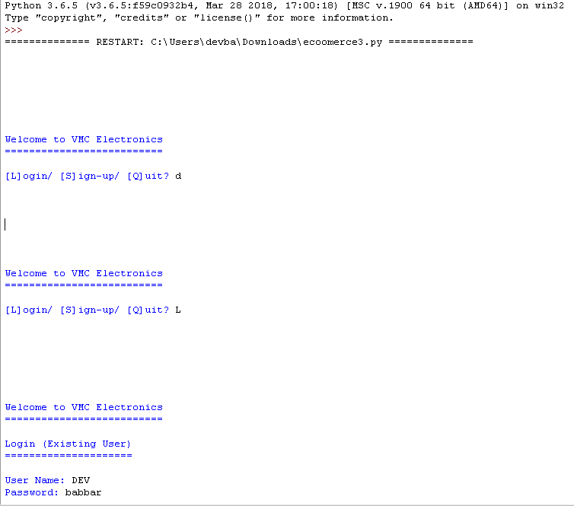
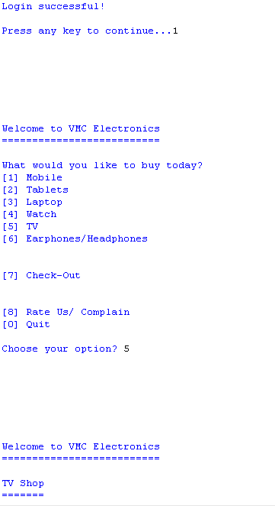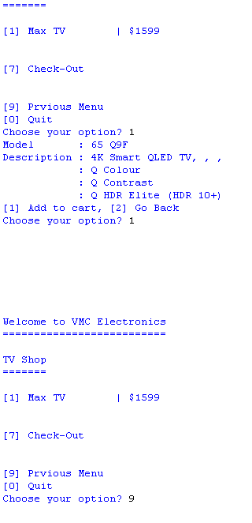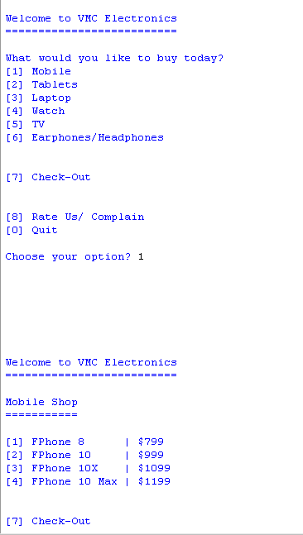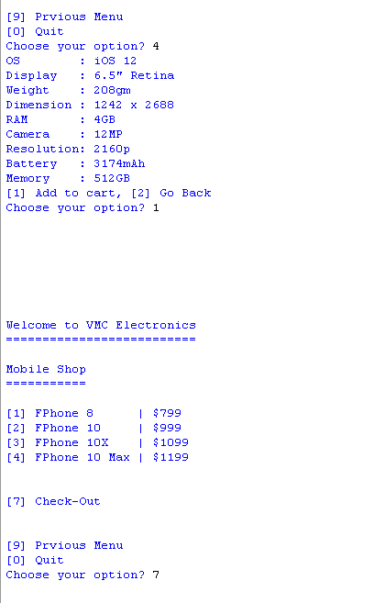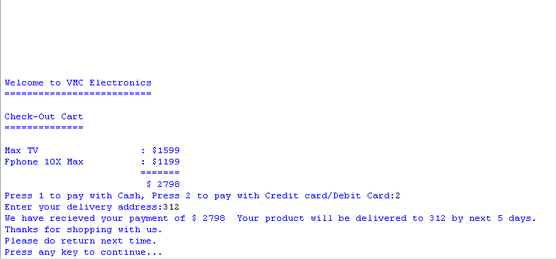

Scope of Improvement

- We can connect some websites to our code to get existing products and increase number of products.
- We can change colors of text to categorize the products and make them look unique.
- Sort the products.
- We can make it more realistic like websites of Apple and Samsung.
- Taking credit card/debit card information and also adding more payment options.
- Using google maps we can also set the minimum and maximum area covered by a particular vehicle type.

Bibliography

Apple’s Official Website
https://www.apple.com/

Learning to add delay in printing
https://stackoverflow.com/questions/5449956/how-to-add-a-delay-for-a-2-or-3-seconds

Learning global variable in a function
https://www.geeksforgeeks.org/global-local-variables-python/

Getting specifications of products
https://www.gsmarena.com/

